FUNDAMENTALS OF NETWORK SECURITY AND DEFENCE
LEARNER GUIDE

Module Code | 252901001-KM-02
NQF Level | 5
Credits | 12
Curriculum Code | 252901001
Qualification Title | Occupational Certificate: Cybersecurity Analyst
SAQA QUAL ID | 118986

Name
Contact Address
Telephone (H)
Telephone (W)
Facsimile
Cellular
E-mail

Note to the learner
This Learner Guide provides a comprehensive overview of the module. It is designed to improve the skills and knowledge of learners, and thus enabling them to effectively and efficiently complete specific tasks.
Entry Requirements

- NQF 4
Provider Accreditation Requirements for the Knowledge Module

Physical Requirements
- The provider must have lesson plans and structured learning material or provide learners with access to structured learning material that addresses all the topics in all the knowledge modules as well as the applied knowledge in the practical skills.
- QCTO/ MICT SETA requirements

Human Resource Requirements:
- Lecturer/learner ratio of 1:20 (Maximum)
- Qualification of lecturer (SME):
    - NQF 6 in industry recognised qualifications with 1 years’ experience in the IT industry
    - CYBERSECURITY vendor certification
- Assessors and moderators: accredited by the MICT SETA
Legal Requirements
- Legal (product) licences to use the software for learning and training
- OHS compliance certificate
- Ethical clearance (where necessary)
Module Purpose

The main focus of the learning in this knowledge module is to build an understanding of the principles and techniques applied in the editing and proofreading processes Network Security and Defence
Topic elements to be covered include
The learning will enable learners to demonstrate an understanding of:
- KM-02-KT01: Introduction to network security
- KM-02-KT02: Network risk and vulnerability management
- KM-02-KT03: Network defense fundamentals
- KM-02-KT04: Monitoring for breaches and attacks
- KM-02-KT05: Network incident response and management

Venue, Date and Time:
Consult your facilitator should there be any changes to the venue, date and/or time.
Refer to your timetable
Assessments

The only way to establish whether you are competent and have accomplished the learning outcomes is through continuous assessments. This assessment process involves interpreting evidence about your ability to perform certain tasks. You will be required to perform certain procedures and tasks during the training programmer and will be assessed on them to certify your competence.

This module includes assessments in the form of self-evaluations/activities and exercises. The exercises, activities and self-assessments will be done in pairs, groups or on your own. These exercises/activities or self-assessments (Learner workbook) must be handed to the facilitator. It will be added to your portfolio of evidence, which will be proof signed by your facilitator that you have successfully performed these tasks.

Listen carefully to the instructions of the facilitator and do the given activities in the time given to you.

KM-02-KT01: Introduction to network security
Topic elements to be covered include:
- KT0101Governance and legislation
- KT0102Security policy
- KT0103Physical security (e.g. biometric authentication)
- KT0104Web content filters
- KT0105Need for protection of privacy and data

KT0101 Governance and legislation

The President has signed the Cybercrimes Act into law. Get an overview of the Act and know the practical implications. We have studied the Cybercrimes Act over the years so that you don’t have to. We provide you with an overview below. Why is it necessary? Who is affected? What action do you need to take? What does it deal with? We answer these questions in this article.
This law has severe consequences if you don’t comply. We have a half-day online workshop to help you get a deeper understanding of the impact of the Cybercrimes Act on your organisation.
Why do we need the Cybercrimes Act?
Many people will be asking – Do we need the Cybercrimes Act? Cybercrime is on the increase and the Cybercrimes Act aims to keep people safe from criminals, terrorists, and other states. It also consolidates cybercrime laws into one place. Essentially, it aims to stop cybercrime and improve the security of the country.
Who is affected by it?
The practical impact of the Cybercrimes Act on all organisations and all individuals is significant and unfortunately mostly negative. We thought it had been fixed but it hasn’t. Law enforcement wants to curtail our freedom by making everyday things a crime. It impacts all of us who process data or use a computer. Individuals, parents, journalists, organisations, banks and many others will probably commit many offences daily. People involved with IT (or data protection) regulatory compliance.
- All Electronic Communications Service Providers (ECSPs).
- Financial institutions.
- Representatives from various government departments.
- Cybercriminals and terrorists.
- Providers or vendors of software or hardware tools that could be used to commit offences.
- Information security experts.
- Everyone who uses a computer or the internet.
- The Police Service.
The timeline
The Cybercrimes Act was first published as the Cybercrimes and Cybersecurity Bill on 28 August 2015, updated on 19 January 2017 and was introduced in Parliament on 22 February 2017. The Bill sat with Parliament for a while as there was a strong push by the old regime in government to enact the Bill in its then-current form. There were extensive comments on the Bill during the public participation period in 2017, and particularly on onerous aspects of the Bill. Those comments were considered and incorporated into the new Cybercrimes Bill that was published in October 2018. The Bill was revived by the National Council of Provinces (NCOP) who opened another period of public participation from various stakeholders since October 2019. Yet again, NCOP received extensive comments and proposed changes. In June 2020, NCOP adopted the Cybercrimes Bill with their proposed changes. The Bill was sent back to the National Assembly for concurrence in July 2020. The Bill was passed by both houses of Parliament in December 2020 and was sent to the President to assent.

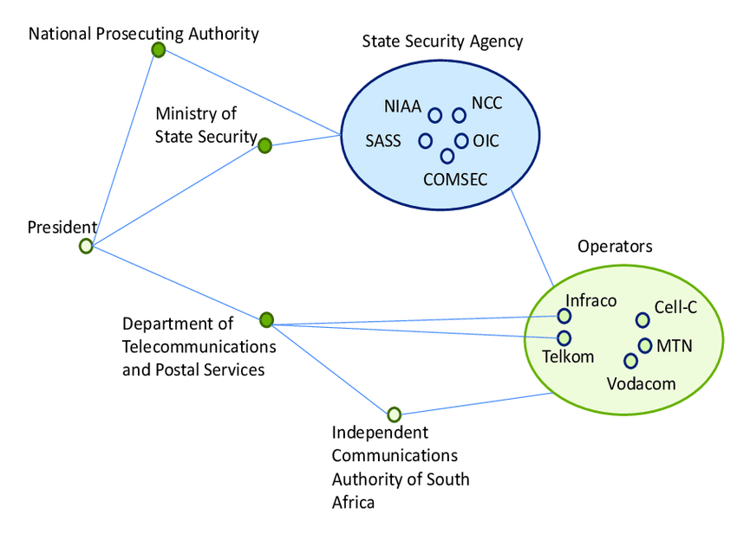
Cybersecurity is a growing concern for governments, with the push for universal access to the Internet, the increasing ubiquity of social networks and the growing reliance on digital government service, and given a growing range of threats from foreign powers, terrorists and criminals. These complex issues span all government ministries, their agencies and contractors, plus provincial and municipal government, and require the state to create legal frameworks and agencies to protect data and offer advice to businesses and citizens, plus ensuring a sufficient supply of skilled technicians and engineers. In the case of South Africa, its government responded in 2015 with a National Cybersecurity Policy Framework (NCPF), with implementation led by the Ministry of State Security. The Protection of Personal Information (POPI) Act of 2013 created the Information Regulator to ensure data privacy. The POPI regime is only being implemented slowly and has overly wide exemptions for national security. South Africa lags behind advanced economies in cybersecurity legislation, in government coordination, in engagement with business and citizens, and in the supply of skilled labour. Delays have meant it lacks the experiences obtained in faster moving countries, and the improvements they have made to their policies and, especially, implementation. Parliament has neither pressed the government for faster action nor explored areas where powers might have been taken that infringe human rights

KT0102 Security policy
What is a security policy?
A security policy (also called an information security policy or IT security policy) is a document that spells out the rules, expectations, and overall approach that an organization uses to maintain the confidentiality, integrity, and availability of its data. Security policies exist at many different levels, from high-level constructs that describe an enterprise’s general security goals and principles to documents addressing specific issues, such as remote access or Wi-Fi use.
A security policy is frequently used in conjunction with other types of documentation such as standard operating procedures. These documents work together to help the company achieve its security goals. The policy defines the overall strategy and security stance, with the other documents helping build structure around that practice. You can think of a security policy as answering the “what” and “why,” while procedures, standards, and guidelines answer the “how.”
Four reasons a security policy is important
Security policies may seem like just another layer of bureaucracy, but in truth, they are a vitally important component in any information security program. Some of the benefits of a well-designed and implemented security policy include:
1. Guides the implementation of technical controls
A security policy doesn’t provide specific low-level technical guidance, but it does spell out the intentions and expectations of senior management in regard to security. It’s then up to the security or IT teams to translate these intentions into specific technical actions.
For example, a policy might state that only authorized users should be granted access to proprietary company information. The specific authentication systems and access control rules used to implement this policy can change over time, but the general intent remains the same. Without a place to start from, the security or IT teams can only guess senior management’s desires. This can lead to inconsistent application of security controls across different groups and business entities.
2. Sets clear expectations
Without a security policy, each employee or user will be left to his or her own judgment in deciding what’s appropriate and what’s not. This can lead to disaster when different employees apply different standards.
Is it appropriate to use a company device for personal use? Can a manager share passwords with their direct reports for the sake of convenience? What about installing unapproved software? Without clear policies, different employees might answer these questions in different ways. A security policy should also clearly spell out how compliance is monitored and enforced.
3. Helps meet regulatory and compliance requirements
Documented security policies are a requirement of legislation like HIPAA and Sarbanes-Oxley, as well as regulations and standards like PCI-DSS, ISO 27001, and SOC2. Even when not explicitly required, a security policy is often a practical necessity in crafting a strategy to meet increasingly stringent security and data privacy requirements.
4. Improves organizational efficiency and helps meet business objectives
A good security policy can enhance an organization’s efficiency. Its policies get everyone on the same page, avoid duplication of effort, and provide consistency in monitoring and enforcing compliance. Security policies should also provide clear guidance for when policy exceptions are granted, and by whom.
To achieve these benefits, in addition to being implemented and followed, the policy will also need to be aligned with the business goals and culture of the organization.
Three types of security policies
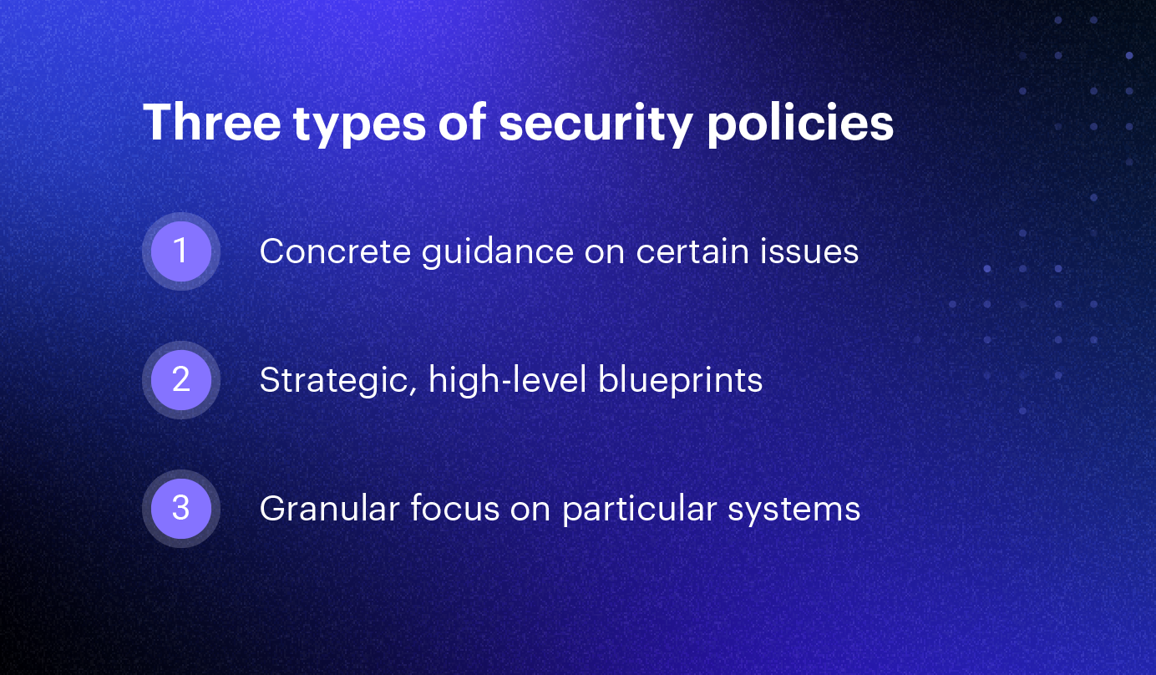
Security policies can vary in scope, applicability, and complexity, according to the needs of different organizations. While there’s no universal model for security policies, the National Institutes of Standards and Technology (NIST) spells out three distinct types in Special Publication (SP) 800-12:
1. Program policy
Program policies are strategic, high-level blueprints that guide an organization’s information security program. They spell out the purpose and scope of the program, as well as define roles and responsibilities and compliance mechanisms. Also known as master or organizational policies, these documents are crafted with high levels of input from senior management and are typically technology agnostic. They are the least frequently updated type of policy, as they should be written at a high enough level to remain relevant even through technical and organizational changes.
2. Issue-specific policy
Issue-specific policies build upon the generic security policy and provide more concrete guidance on certain issues relevant to an organization’s workforce. Common examples could include a network security policy, bring-your-own-device (BYOD) policy, social media policy, or remote work policy. These may address specific technology areas but are usually more generic. A remote access policy might state that offsite access is only possible through a company-approved and supported VPN, but that policy probably won’t name a specific VPN client. This way, the company can change vendors without major updates.
3. System-specific policy
A system-specific policy is the most granular type of IT security policy, focusing on a particular type of system, such as a firewall or web server, or even an individual computer. In contrast to the issue-specific policies, system-specific policies may be most relevant to the technical personnel that maintains them. NIST states that system-specific policies should consist of both a security objective and operational rules. IT and security teams are heavily involved in the creation, implementation, and enforcement of system-specific policies but the key decisions and rules are still made by senior management.
Seven elements of an effective security policy
Security policies are an essential component of an information security program, and need to be properly crafted, implemented, and enforced. An effective security policy should contain the following elements:
1. Clear purpose and objectives
This is especially important for program policies. Remember that many employees have little knowledge of security threats, and may view any type of security control as a burden. A clear mission statement or purpose spelled out at the top level of a security policy should help the entire organization understand the importance of information security.
2. Scope and applicability
Every security policy, regardless of type, should include a scope or statement of applicability that clearly states to who the policy applies. This can be based around the geographic region, business unit, job role, or any other organizational concept so long as it's properly defined.
3. Commitment from senior management
Security policies are meant to communicate intent from senior management, ideally at the C-suite or board level. Without buy-in from this level of leadership, any security program is likely to fail. To succeed, your policies need to be communicated to employees, updated regularly, and enforced consistently. A lack of management support makes all of this difficult if not impossible.
4. Realistic and enforceable policies
While it might be tempting to base your security policy on a model of perfection, you must remember that your employees live in the real world. An overly burdensome policy isn’t likely to be widely adopted. Likewise, a policy with no mechanism for enforcement could easily be ignored by a significant number of employees.
5. Clear definitions of important terms
Remember that the audience for a security policy is often non-technical. Concise and jargon-free language is important, and any technical terms in the document should be clearly defined.
6. Tailored to the organization’s risk appetite
Risk can never be completely eliminated, but it’s up to each organization’s management to decide what level of risk is acceptable. A security policy must take this risk appetite into account, as it will affect the types of topics covered.
7. Up-to-date information
Security policy updates are crucial to maintaining effectiveness. While the program or master policy may not need to change frequently, it should still be reviewed on a regular basis. Issue-specific policies will need to be updated more often as technology, workforce trends, and other factors change. You may find new policies are also needed over time: BYOD and remote access policies are great examples of policies that have become ubiquitous only over the last decade or so.

KT0103 Physical security (e.g. biometric authentication)
What is Biometric Authentication?
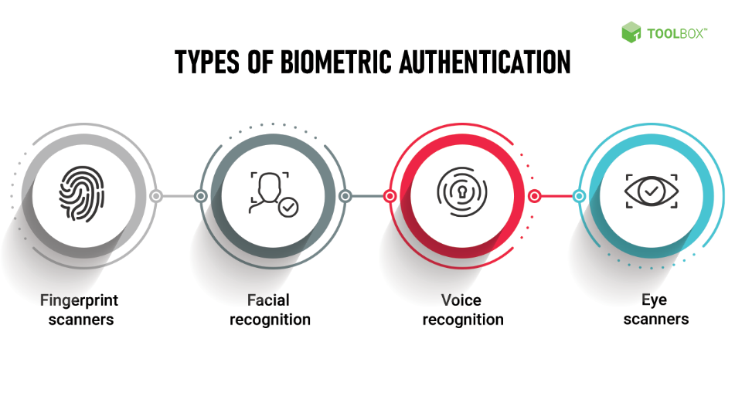
Authentication is a way to verify, beyond a doubt, that a person is who they say they are. Biometric authentication performs this verification by checking distinctive biological or behavioral characteristics.
An authentication system works by comparing provided data with validated user information stored in a database. In traditional systems, this information is passwords. In biometric authentication, this information is defined as physical or behavioral traits.
For example, in a facial recognition system, different facial features are processed and converted into numerical data, which is stored in a database. When a person tries to log in, the system recaptures their face, extracts numerical data, and then compares it with what’s stored in the database. Other types of biometric authentication are:
- Fingerprint scanning
- DNA matching
- Retina scanning
- Vein scanning
- Behavioral biometrics
Behavioral biometrics verify identity by analyzing physical and cognitive behavior of a user. They use machine learning algorithms to determine patterns in user behavior and activities. These patterns are then used to detect whether someone is who they say they are.
Examples of behavioral biometrics are:
- Touchscreen use (how much area of the screen are they using)
- Typing dynamics (keyboard shortcuts or typing speed)
- Mouse activity
Is Biometric Authentication Hackable?
The whole point of biometrics is that they are unique. Knowing that, you may think that biometric authentication can’t be hacked. But that’s not true. Just like any other system, biometric authentication isn’t hack-proof. Modern AI algorithms can be used to generate fingerprints, which can deceive fingerprint scanners.
Moreover, several vulnerabilities have been observed in the data collection, processing, matching, and enrollment processes of even the most sophisticated biometric systems.
What is Multimodal Biometric Authentication?
A unimodal biometric authentication system verifies only one distinct characteristic, e.g. a face or a retina. But as we just saw, such a system is susceptible to spoofing.
This is where multimodal biometric authentication can help. It’s an approach in which various biometrics are checked during identity verification. This makes it much harder for a malicious actor to spoof.
For example, a hacker may be able to find a person’s photo on the internet, which they use to successfully trick a facial recognition system. But if the system requires them to provide additional info, e.g. a video of the person saying their password, they are highly unlikely to find it.
Additionally, combining physical and behavioral biometrics can also enhance your security posture. Even if a malicious actor manages to spoof a fingerprint, the system can detect change in behavior and deny entry. E.g., their speed of interaction with the system may be slower than the real user, or they are using keyboard shortcuts that the real user never used.
The Good
Biometrics are a much needed improvement over passwords. Passwords are very easy to hack. Sometimes, all a hacker needs are a person’s birthdate, and the name of their cat. Biometrics on the other hand, are much harder to obtain.
You won’t find a person’s biometric data written on a sticky note, or auto-filled in their browser. Attackers thus find it much harder to break into passwordless biometric systems, especially those using multimodal authentication.
A main reason for the popularity and prevalence of biometric authentication is that users find it much more convenient. No need to remember a complex password, or change one every other month. Just put your finger over a keypad, or look into an eye scanner, and you are in.
Some systems, such as facial recognition, can even authenticate without the user consciously making a gesture. Simply moving into a room, or sitting in front of your computer, can suffice.
Biometric authentication and zero-trust models go hand-in-hand. To build a true zero trust model, one where nothing is intrinsically trusted, you can depend on the resilient identity validation of biometric systems.

KT0104 Web content filters

LinkedIn
Twitter
Facebook
What is Web Content Filtering?
Web content filtering is a technicque that blocks and screens access to inappropriate or unsafe web content. Uses include a company keeping employees from visiting known spam sites or school systems restricting students from adult content.
How does web content filtering work?
Content filters come as either hardware or software and are often part of a firewall. As part of a firewall they're likely to serve security purposes. However, the action of content filtering can refer to the implementation of a company's policies in regards to information system usage through the company’s network. For example, internet content filters in offices serve to filter non-work related content such as social-networking sites unrelated to the work environment or deemed distractions. The technology behind web content filtering establishes rules and patterns that apply to the harmful websites that may seek access. By using predetermined rules, the content filter identifies commonalities such as objects within images or text strings such as keywords and groups them into categories such as adult, gambling, gaming, sports, and so on. Once there is a match from a site seeking access, they are marked as objectionable and denied access.
Keeping undesirable content from minors is one of the more apparent reasons for individual use of web content filtering. However, content filtering is becoming an essential component of the workplace. Domain Internet System (DNS) filtering refers to blocking specific sites by pre-identifying their IP address to ensure the prevention of access. These sites include productivity sinks such as social media, gambling, adult content, and websites that pose malware risk.
Why is web content filtering important?
Hacking, phishing, viruses, and malware are some of the biggest threats to any business. Phishing, for example, is when hackers obtain sensitive information through deception, such as duping employees to log in to falsified companies to gain login credentials. Undeniably, the loss or corruption of sensitive data such as login details, personal information, accounting details, and legal documents can be catastrophic to any company. Hence the importance of content filtering protocols. Web content filtering has a multitude of benefits for both individual users and organizations.

Protect minors from inappropriate content
The most obvious benefit and use of web content filtering for individual users is the successful protection of children from inappropriate content such as pornographic and violent content. In a fast-paced world, parents may not always be physically present to watch and monitor the kind of content their children are exposed to, additionally they may not know all of the sites to restrict. The use of content filtering as part of a firewall helps achieve complete control over what is accessible and not by referencing the rules placed by the user or administrator.
Reduced malware infections
By blocking access to known sites that may carry a high risk of malware, you can protect your data and users before those sites have a chance to introduce malicious payloads. For example, using DNS filtering users can significantly limit the threats and, consequently, reduce the remediation workload for IT professionals and MSPs. DNS filtering is so effective that it can stop Internet-borne malware before it reaches the network. Besides restricting access through domain names, firewalls with web content filtering systems can also scrutinize and scan web pages to determine what might contain threats.
Protection against exploit kits
Cybersecurity technology is continually evolving, and at the same time, hackers are also developing smarter ways to illegally access your data and networks. Exploit kits contain code designed specifically to attack web browsers' vulnerabilities through browser extensions and plugins. Unknowingly a user will visit a malicious URL that has an exploit kit that triggers a malware download once the vulnerabilities are exploited. Content filters can effectively identify exploit kits and block off access before any download is committed.
Increased staff productivity
Social media is a notorious productivity sink, distracting, takes up huge chunks of valuable work time, and leads to reduced productivity. Restricting access works to increase productivity significantly. However, some industries require social media savviness for operations. In these industries, a different set of sites become productivity sinks, such as online shopping and streaming sites. There is absolutely no reason why employees should be watching movies while they should be working. In addition to restricting access to websites that are distracting, it is vital to consider other avenues that could pose a threat, such as downloading suspicious files, opening suspicious emails, and responding to unverified contacts.
Network bandwidth efficiency
Non-work-related internet usage significantly saps your network bandwidth. By limiting access to these sites, you achieve increased network bandwidth efficiency with faster connections. To achieve network bandwidth efficiency, you can educate your team about the merits of a consistently fast network or set limits on video streaming sites such as YouTube, a 'bandwidth hogger.’
Reduce inappropriate content
Implementing internet content filters helps protect your employees from malware and phishing attacks. Educating them on the importance of these measures also goes a long way to guarantee efficiency; however, in the instance that some of them still seek out risky sites, the filtering protocols protect your network.
Minimized company liability
An organization that is active in monitoring their staff's web usage is better placed to mitigate disasters resulting from the misuse of the internet. Liabilities could surround matters with knowingly or unknowingly posting offensive content on blogs or social media, hateful content that is discriminatory or vulgar, cyberbullying, or downloading copyright-protected material. With the world becoming such a radicalized space, it is important to always protect your company ad your brand by carefully monitoring the information you and your staff let in, or send out.

KT0105 Need for protection of privacy and data
Why is Data Protection Important?


Data protection is important, since it prevents the information of an organization from fraudulent activities, hacking, phishing, and identity theft. Any organization that wants to work effectively need to ensure the safety of their information by implementing a data protection plan. As the amount of data stored and created increases, so does the importance of data protection. Data breaches and cyberattacks can cause devastating damages. Organizations need to proactively protect their data and regularly update their protective measures.
Ultimately, the key principle and importance of data protection is safeguarding and protecting data from different threats and under different circumstances. The following article elaborates more on data protection and its importance.
Key Elements of Data Protection
One very important data protection model is the CIA triad, where the three letters of the name represent the three elements of data protection: confidentiality, integrity, and availability. This model was developed to help individuals and organizations develop a holistic approach to data protection. The three elements are defined as follows:
- Confidentiality: The data is retrieved only by authorized operators with appropriate credentials.
- Integrity: All the data stored within an organization is reliable, precise, and not subject to any unjustified changes.
- Availability: The data stored is safely and readily available whenever needed.
The Type of Data That Requires Protection
Vital information of customers, such as names, addresses, emails, phone numbers, health information, or bank details, are all data that should be carefully stored and protected. Data protection gains special importance when the information concerns customers. If such information gets in the wrong hands, it can compromise people’s safety in many forms, including personal integrity, physical safety, and financial security. Stolen information can also be used to create fake profiles and commit fraud.
The implementation of a privacy information management system (PIMS) based on the requirements and guidance of ISO/IEC 27701 allows organizations to assess, treat, and reduce risks associated with the collection, maintenance, and processing of personal information.
If you wish to pursue a career in assisting organizations in this field, PECB offers a set of ISO/IEC 27701 training courses that provide the skills, methods, and tools needed to maintain a PIMS in compliance with ISO/IEC 27701.
Data Protection Best Practices
There are different data protection management practices. Some of the most commonly used include:
- Data loss prevention (DLP): A set of tools and processes used to secure data from theft, loss, misuse, deletion, or other illegal or inappropriate forms of contact
- Firewalls: Tools used for monitoring and filtering the network traffic to ensure data is transferred or accessed only by authorized users
- Encryption: Altering the content of data based on an algorithm that can be reversed only with the right encryption password or key.
Encryption protects data even if it gets stolen, since the data would be unreadable.
- Data erasure: Deleting data that is no longer needed or relevant
This is also a requirement of the GDPR.
- Data resiliency: Building resiliency systems within the software and hardware of an organization’s system to ensure the security in case of natural disasters or power outages
- Data backups: A plan to securely back up data in case of failure or breach
Such backup plans may include a separate physical disk or cloud.
Another important certification form is that related to the General Data Protection Regulation (GDPR). PECB offers GDPR training courses that provide the knowledge, tools, and methods needed to comply with the GDPR requirements. This also increases customer trust and provides a competitive edge. PECB’s data protection certification will help you to protect an organization’s reputation, facilitate data access, ensure a stronger rule enforcement, enable adequate access control, minimize security breaches, attract new customers and keep the existing ones, and so on.
Data Protection Framework
As the number of organizations that process the personally identifiable information (PII) increases, so does the need for such organizations to ensure the safety and privacy of data. PECB offers ISO/IEC 29100 training and certification that presents best practices related to the protection of the PII.
It is essential for organizations to implement a data protection framework that provides guidance on the protection of PII. The framework will help an organization to ensure that all data stored in their servers is protected and reasonably used. It will also give the organization guidance and structure on any changes needed and the specific use of such changes.
Additionally, using a well-known data protection framework may decrease the risk of incidents, and regulators may have greater effort to protect the data in such cases. A data protection framework may also adapt to meet the evolving data protection requirements, while data protection laws may be subject to changes. Data protection standards may help you and your organization to better manage your customer’s data.

Internal Assessment Criteria and Weight
- IAC0101The implications of governance and legislation on cybersecurity are reasoned.
- IAC0102The importance of protection of privacy and data is justified

KM-02-KT02: Network risk and vulnerability management
Topic elements to be covered include:
- KT0201Network security threats, vulnerabilities, and attacks
- KT0202Knowledge on how to protect, detect, and respond to network attacks

KT0201 Network security threats, vulnerabilities, and attacks
What Is A Network Vulnerability?

A network vulnerability is a weakness or flaw in software, hardware, or organizational processes, which when compromised by a threat, can result in a security breach.
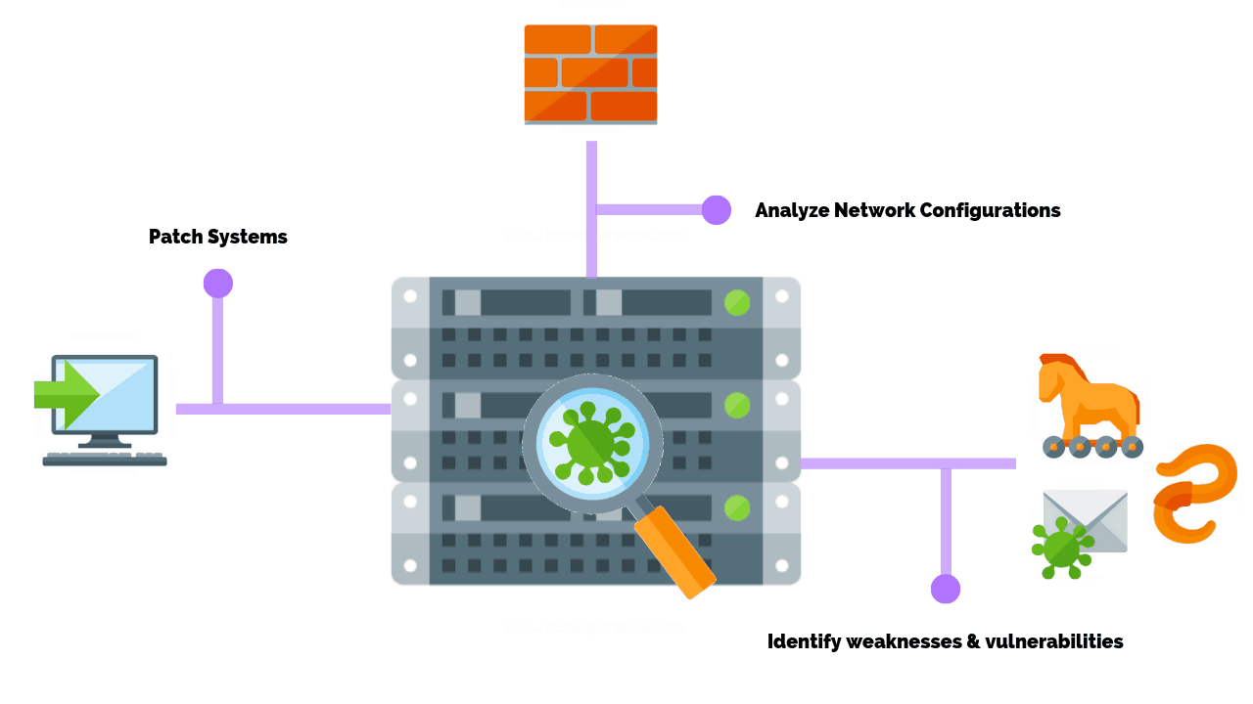
Nonphysical network vulnerabilities typically involve software or data. For example, an operating system (OS) might be vulnerable to network attacks if it’s not updated with the latest security patches. If left unpatched a virus could infect the OS, the host that it’s located on, and potentially the entire network.

Physical network vulnerabilities involve the physical protection of an asset such as locking a server in a rack closet or securing an entry point with a turnstile.
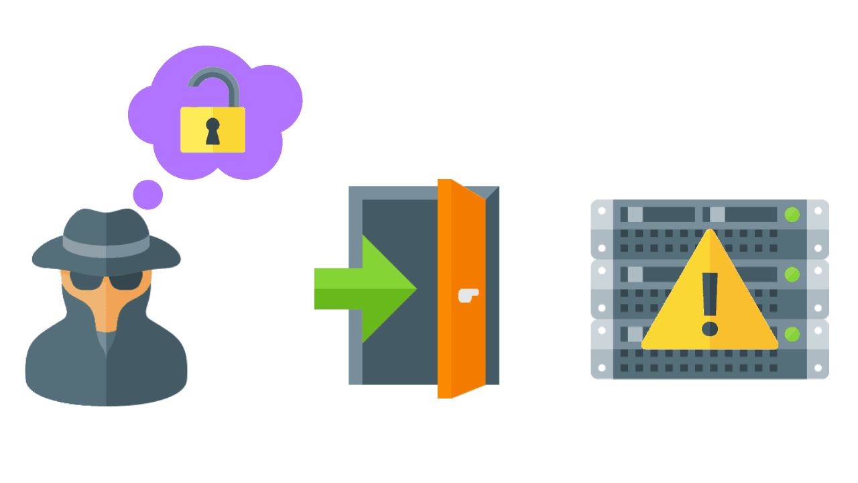
Servers have some of the strongest physical security controls in place as they contain valuable data and trade secrets or perform a revenue-generating function like a web server hosting an eCommerce site. Often stored in off-site data centers or in secure rooms, servers should be protected with personalized access cards and biometric scanners.

Prior to investing in security controls, a vulnerability risk assessment is performed to quantify the cost and acceptable loss of the equipment and its function. As with all things in cyber security it’s a balancing act of resources vs functionality that makes for the most practical solutions.

What Are The Different Types Of Network Vulnerabilities?

Network vulnerabilities come in many forms but the most common types are:

- Malware, short for malicious software, such as Trojans, viruses, and worms that are installed on a user’s machine or a host server.
- Social engineering attacks that fool users into giving up personal information such as a username or password.
- Outdated or unpatched software that exposes the systems running the application and potentially the entire network.
- Misconfigured firewalls / operating systems that allow or have default policies enabled.

It’s important that your network security team address these factors when assessing the overall security posture of your systems.

When left unchecked, these vulnerabilities can lead to more advanced attacks such as a DDoS (distributed denial of services) attack, which can bring a network down to a crawl or prevent users from accessing it altogether.

Malware (Malicious Software)

Malware is a malicious software that is unknowingly purchased, downloaded, or installed. The use of malware to exploit network vulnerabilities continue to rise hitting an all time high of 812.67 million infected devices in 2018.
Systems infected with malware will present with symptoms such as running slower, sending emails without user action, randomly rebooting, or starting unknown processes.

The most common types of malware include:

- Viruses
- Keyloggers
- Worms
- Trojans
- Ransomware
- Logic Bombs
- Bots/Botnets
- Adware & Spyware
- Rootkits

Malware is often deployed through phishing emails. In short, threat actors send emails to employees containing links to websites or embed attachments within the email itself. If an action is taken, such as clicking the link or downloading the attachment, the malicious code is executed and you can consider yourself breached.


Viruses

A virus is the most common type of malware attack. In order for a virus to infect a system it requires a user to click or copy it to media or a host. Most viruses self-replicate without the knowledge of the user. These viruses can be spread from one system to another via email, instant messaging, website downloads, removable media (USB), and network connections.

Some file types are more susceptible to virus infections – .doc/docx, .exe, .html, .xls/.xlsx, .zip. Viruses typically remain dormant until it has spread on to a network or a number of devices before delivering the payload.


Keyloggers

Keylogging, or keyboard capturing, logs a user’s keystrokes and sends data to the threat actor. Users are typically unaware that their actions are being monitored. While there are use cases for employers using keyloggers to track employee activity, they’re mostly used to steal passwords or sensitive data. Keyloggers can be a physical wire discreetly connected to a peripheral like a keyboard, or installed by a Trojan.


Worms

Similar to a virus, a worm can also self-replicate and spread full copies and segments of itself via network connections, email attachments, and instant messages. Unlike viruses, however, a worm does not require a host program in order to run, self-replicate, and propagate. Worms are commonly used against email servers, web servers, and database servers. Once infected, worms spread quickly over the internet and computer networks.


Trojan Horses

Trojan horse programs are malware that is disguised as legitimate software. A Trojan horse program will hide on your computer until it’s called upon. When activated, Trojans can allow threat actors to spy on you, steal your sensitive data, and gain backdoor access to your system.

Trojans are commonly downloaded through email attachments, website downloads, and instant messages. Social engineering tactics are typically deployed to trick users into loading and executing Trojans on their systems. Unlike computer viruses and worms, Trojans are not able to self-replicate.


Ransomware / Crypto-Malware

Ransomware is a type of malware designed to lock users out of their system or deny access to data until a ransom is paid. Crypto-Malware is a type of ransomware that encrypts user files and requires payment within a time frame and often through a digital currency like Bitcoin.

KT0202 Knowledge on how to protect, detect, and respond to network attacks
What Is a Network Attack?

A network attack is an attempt to gain unauthorized access to an organization’s network, with the objective of stealing data or perform other malicious activity. There are two main types of network attacks:
- Passive: Attackers gain access to a network and can monitor or steal sensitive information, but without making any change to the data, leaving it intact.
- Active: Attackers not only gain unauthorized access but also modify data, either deleting, encrypting or otherwise harming it.
We distinguish network attacks from several other types of attacks:
- Endpoint attacks—gaining unauthorized access to user devices, servers or other endpoints, typically compromising them by infecting them with malware.
- Malware attacks—infecting IT resources with malware, allowing attackers to compromise systems, steal data and do damage. These also include ransomware attacks.
- Vulnerabilities, exploits and attacks—exploiting vulnerabilities in software used in the organization, to gain unauthorized access, compromise or sabotage systems.
- Advanced persistent threats—these are complex multilayered threats, which include network attacks but also other attack types.
In a network attack, attackers are focused on penetrating the corporate network perimeter and gaining access to internal systems. Very often, once inside attackers will combine other types of attacks, for example compromising an endpoint, spreading malware or exploiting a vulnerability in a system within the network.
What are the Common Types of Network Attacks?
Following are common threat vectors attackers can use to penetrate your network.
1. Unauthorized access
Unauthorized access refers to attackers accessing a network without receiving permission. Among the causes of unauthorized access attacks are weak passwords, lacking protection against social engineering, previously compromised accounts, and insider threats.
2. Distributed Denial of Service (DDoS) attacks
Attackers build botnets, large fleets of compromised devices, and use them to direct false traffic at your network or servers. DDoS can occur at the network level, for example by sending huge volumes of SYN/ACC packets which can overwhelm a server, or at the application level, for example by performing complex SQL queries that bring a database to its knees.
3. Man in the middle attacks
A man in the middle attack involves attackers intercepting traffic, either between your network and external sites or within your network. If communication protocols are not secured or attackers find a way to circumvent that security, they can steal data that is being transmitted, obtain user credentials and hijack their sessions.
4. Code and SQL injection attacks
Many websites accept user inputs and fail to validate and sanitize those inputs. Attackers can then fill out a form or make an API call, passing malicious code instead of the expected data values. The code is executed on the server and allows attackers to compromise it.
5. Privilege escalation
Once attackers penetrate your network, they can use privilege escalation to expand their reach. Horizontal privilege escalation involves attackers gaining access to additional, adjacent systems, and vertical escalation means attackers gain a higher level of privileges for the same systems.
6. Insider threats
A network is especially vulnerable to malicious insiders, who already have privileged access to organizational systems. Insider threats can be difficult to detect and protect against, because insiders do not need to penetrate the network in order to do harm. New technologies like User and Even Behavioral Analytics (UEBA) can help identify suspicious or anomalous behavior by internal users, which can help identify insider attacks.
Network Protection Best Practices
Segregate Your Network
A basic part of avoiding network security threats is dividing a network into zones based on security requirements. This can be done using subnets within the same network, or by creating Virtual Local Area Networks (VLANs), each of which behaves like a complete separate network. Segmentation limits the potential impact of an attack to one zone, and requires attackers to take special measures to penetrate and gain access to other network zones.
Regulate Access to the Internet via Proxy Server
Do not allow network users to access the Internet unchecked. Pass all requests through a transparent proxy, and use it to control and monitor user behavior. Ensure that outbound connections are actually performed by a human and not a bot or other automated mechanism. Whitelist domains to ensure corporate users can only access websites you have explicitly approved.
Place Security Devices Correctly
Place a firewall at every junction of network zones, not just at the network edge. If you can’t deploy full-fledged firewalls everywhere, use the built-in firewall functionality of your switches and routers. Deploy anti-DDoS devices or cloud services at the network edge. Carefully consider where to place strategic devices like load balancers – if they are outside the Demilitarized Zone (DMZ), they won’t be protected by your network security apparatus.
Use Network Address Translation
Network Address Translation (NAT) lets you translate internal IP addresses into addresses accessible on public networks. You can use it to connect multiple computers to the Internet using a single IP address. This provides an extra layer of security, because any inbound or outgoing traffic has to go through a NAT device, and there are fewer IP addresses which makes it difficult for attackers to understand which host they are connecting to.
Monitor Network Traffic
Ensure you have complete visibility of incoming, outgoing and internal network traffic, with the ability to automatically detect threats, and understand their context and impact. Combine data from different security tools to get a clear picture of what is happening on the network, recognizing that many attacks span multiple IT systems, user accounts and threat vectors.
Achieving this level of visibility can be difficult with traditional security tools. Cynet 360 is an integrated security solution offering advanced network analytics, which continuously monitors network traffic, automatically detect malicious activity, and either respond to it automatically or pass context-rich information to security staff.
Use Deception Technology
No network protection measures are 100% successful, and attackers will eventually succeed in penetrating your network. Recognize this and place deception technology in place, which creates decoys across your network, tempting attackers to “attack” them, and letting you observe their plans and techniques. You can use decoys to detect threats in all stages of the attack lifecycle: data files, credentials and network connections.

Internal Assessment Criteria and Weight
- IAC0201Network risk and vulnerability management is evaluated

KM-02-KT03: Network defense fundamentals
Topic elements to be covered include:
- KT0301Network security controls, protocols, and devices
- KT0302Physical security
- KT0303Host security
- KT0304Secure firewall configuration and management
- KT0305Secure IDS configuration and management
- KT0306Secure VPN configuration and management
- KT0307Wireless network defense
- KT0308Data backup and recovery

KT0301 Network security controls, protocols, and devices
Network security protocols are primarily designed to prevent any unauthorized user, application, service or device from accessing network data. This applies to virtually all data types regardless of the network medium used.
Network security protocols generally implement cryptography and encryption techniques to secure the data so that it can only be decrypted with a special algorithm, logical key, mathematical formula and/or a combination of all of them. Some of the popular network security protocols include Secure File Transfer Protocol (SFTP), Secure Hypertext Transfer Protocol (HTTPS) and Secure Socket Layer (SSL).

Network security controls

Network Security Controls are used to ensure the confidentiality, integrity, and availability of the network services.
...
These network security controls include:
- Access Control.
- Identification.
- Authentication.
- Authorization.
- Accounting.
- Cryptography.
- Security Policy.

KT0302 Physical security
What is physical security and how does it work?
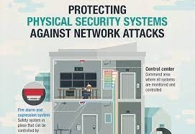
Physical security is the protection of personnel, hardware, software, networks and data from physical actions and events that could cause serious loss or damage to an enterprise, agency or institution. This includes protection from fire, flood, natural disasters, burglary, theft, vandalism and terrorism. While most of these are covered by insurance, physical security's prioritization of damage prevention avoids the time, money and resources lost because of these events.
The physical security framework is made up of three main components: access control, surveillance and testing. The success of an organization's physical security program can often be attributed to how well each of these components is implemented, improved and maintained.
Access control
The key to maximizing one's physical security measures is to limit and control what people have access to sites, facilities and materials. Access control encompasses the measures taken to limit exposure of certain assets to authorized personnel only. Examples of these corporate barriers often include ID badges, keypads and security guards. However, these obstacles can vary greatly in terms of method, approach and cost.
The building is often the first line of defense for most physical security systems. Items such as fences, gates, walls and doors all act as physical deterrents to criminal entry. Additional locks, barbed wire, visible security measures and signs all reduce the number of casual attempts carried out by cybercriminals.
More sophisticated access controls involve a technology-supported approach. ID card scanners and near-field communication (NFC) ID cards are methods of physical authentication that security teams can use to verify the identities of individuals entering and exiting various facilities. Some Swedish companies have recently experimented with embedding NFC microchips below the skin of their employees -- making it extremely difficult to forge or replicate their credentials. Invasive devices like this, however, are much less popular among labor unions, given the degree of physical pain and bodily concern.
Using tactically placed obstacles, organizations can make it more difficult for attackers to access valuable assets and information. Similarly, these barriers increase the time it takes for threat actors to successfully carry out acts of thievery, vandalism or terrorism. The more obstacles that are in place, the more time organizations have to respond to physical security threats and contain them.
But criminals are not the only threat that access controls can minimize. Barriers such as walls and fences can also be used to harden buildings against environmental disasters, such as earthquakes, mudslides and floods. These risks are extremely location-dependent. Organizations that divert resources toward such hardening measures should balance the cost and benefit of their implementation prior to investment.
Surveillance
This is one of the most important physical security components for both prevention and post-incident recovery. Surveillance, in this case, refers to the technology, personnel and resources that organizations use to monitor the activity of different real-world locations and facilities. These examples can include patrol guards, heat sensors and notification systems.
The most common type of surveillance is closed circuit television (CCTV) cameras that record the activity of a combination of areas. The benefit of these surveillance cameras is that they are as valuable in capturing criminal behavior as they are in preventing it. Threat actors who see a CCTV camera are less inclined to break in or vandalize a building out of fear of having their identity recorded. Similarly, if a particular asset or piece of equipment is stolen, surveillance can provide the visual evidence one needs to identify the culprit and their tactics.
Testing
Physical security is a preventative measure and incident response tool. Disaster recovery (DR) plans, for example, center on the quality of one's physical security protocols -- how well a company identifies, responds to and contains a threat. The only way to ensure that such DR policies and procedures will be effective when the time comes is to implement active testing.
Testing is increasingly important, especially when it comes to the unity of an organization. Fire drills are a necessary activity for schools and buildings because they help to coordinate large groups, as well as their method of response. These policy tests should be conducted on a regular basis to practice role assignments and responsibilities and minimize the likelihood of mistakes.
Importance of physical security
As businesses become more dependent on the internet of things (IoT), so does the need for digital and physical security. IoT demands a significant amount of physical security to safeguard data, servers and networks. The rising interconnectedness of IoT has expanded the sphere of physical security. Virtual machines (VMs) and applications that run in the cloud, for example, are only as protected as their physical servers.
Whether organizations invest in first-party or third-party cloud computing services, these data centers need to be sufficiently protected using physical security measures to avoid severe data losses.
Physical security examples
Physical security can take many shapes and forms. The strategies, barriers and techniques that organizations use to support general physical information technology (IT) security, for example, are significantly different from those used to facilitate consistent physical network security. Here are a few physical security examples used to contain and control real-world threats.
Log and trail maintenance
Keeping a record of what is accessed -- and what people attempt to access -- is a reliable way to not only discourage unauthorized users, but create a forensic-friendly data environment.
Multiple failed login attempts and attempted access using a lost card are both physical security tools that organizations can use to reliably track their asset activity. In the case of a security breach, these records can prove incredibly valuable for identifying security weaknesses.
Risk-based approach
One of the most effective ways to optimize a physical security investment is to use a risk-based approach. This is a data analysis technique used to evaluate scenarios based on one's risk profile.
If a business is particularly risk-averse -- such as a credit union or a restaurant -- it will opt to invest in a more expensive physical security system that is more equipped to mitigate risk. Therefore, the amount of resources a company dedicates to its physical security using a risk-based approach should be equivalent to the value it places on risk mitigation.
Accountable access control
By tying access control to individuals, an organization can improve its visibility over personnel activity. Imagine a particular room can only be accessed by a single key, and that key is given to two people. If an asset in that room goes missing, then only those two people are accountable for its disappearance.

KT0303 Host security
Host Security

Installing and maintaining critical system updates is an example of how host-based security is implemented in an industrial network. Many vulnerabilities that hackers exploit are derived from unpatched operating systems and applications. Typically, when a vulnerability is discovered by the software manufacturer, critical updates are issued out soon after to patch it up. Suppose a workstation at a water treatment plant has not received an update patching a vulnerability that would allow a hacker to remotely access the computer. The hacker can infiltrate the plant's network via this vulnerability and cause critical processes to halt, affecting the community's access to clean water.

Critical system updates are used to patch known vulnerabilities in software
Another example would be a Host-Based Intrusion Detection System (HIDS). A HIDS is a tool used to monitor traffic to and from the computer in which it is deployed. The HIDS will then alert network administrators or security analysts when it detects suspicious traffic resembling an intrusion attempt. Large industrial networks, such as those seen in large electrical grids, can benefit greatly from a HIDS due to its versatility. Additionally, security analysts can have a better overview of each computer's traffic since each workstation will have its own dedicated HIDS.
Access Controls
Access controls are perhaps the most common type of security control used in industrial networks. Barriers such as fences and gates are commonly used in conjunction with security guards to ward off potential trespassers to a plant. However, other access controls can be used to defend critical systems in an industrial network. For instance, biometric systems can be used in a nuclear power plant to allow authorized personnel into the power plant's control room. Biometrics refers to any measurements or analysis of the human body. Biometrics are at times preferred to passcodes or pins since they are difficult to reproduce and they are something the user always has with them.

KT0304 Secure firewall configuration and management
What is Firewall Configuration?
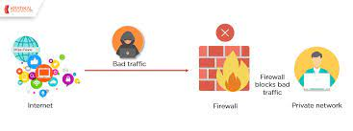
Firewalls are a core component of an enterprise security strategy. Firewalls can protect against cyber attacks, data exfiltration, and other threats by monitoring network traffic and blocking suspected malicious traffic.
One of the main ways that firewalls determine whether to permit or block a connection is based on a set of predefined rules or policies. These rules may specify that traffic to a particular IP address or port should be permitted or blocked. Firewall configuration is the process of setting up these rules and configuring other security settings on a firewall.
The Importance of Firewall Configuration
Firewalls determine which traffic can pass through a network boundary based largely on a set of predefined rules. Whether or not these rules are properly configured determines whether a firewall effectively blocks malicious network connections or accidentally blocks legitimate business communications. Additionally, if a firewall is not properly configured and secured, cyber threat actors can exploit vulnerabilities and security issues to gain access to the firewall and the protected network.
Firewall Configuration Challenges
Proper firewall configurations are essential to corporate cybersecurity. Some common firewall configuration mistakes include:
- Overly Broad Policies: Defining broad firewall policies can help to quickly set up a firewall, but it leaves the organization open to attack. Firewall policies should be tightly defined based on business needs and the principle of least privilege.
- Inbound-Only Rules: Often, firewall policies are focused on inbound traffic and threats originating outside of the organization. However, allowing all outbound traffic can enable data exfiltration, malware command and control, and other threats.
- Lax Authentication Methods: The use of lax and insecure authentication methods could undermine corporate password and authentication security policies. Firewalls should be configured to only permit strong methods of authentication such as Multi-factor Authentication.
- Failing to Secure the Firewall: A firewall is designed to restrict access to corporate resources, but it can also be a target of attack. Leaving ports and risky management services accessible can grant cybercriminals access to the firewall and enterprise network.
- Inadequate Monitoring: Firewall configurations can miss evolving threats or block new types of legitimate business traffic. Regular monitoring is essential to ensure that any attempted attacks are properly detected and blocked and that firewall configurations meet the needs of the business.
Firewall Best Practices for Securing the Network
A firewall is a crucial component of an enterprise network security strategy, and proper configurations and security settings are essential to its effectiveness. Some important best practices for firewall configuration and security include:
- Harden and Properly Configure the Firewall: If the vendor has not already done so, ensure that the firewall’s operating system is appropriately hardened and up-to-date on patches.
- Plan your Firewall Deployment: Firewalls define network boundaries, which is essential for network segmentation and zero-trust security. Network zones should be defined based on business needs, and, since a firewall is a potential single point of failure, firewalls should ideally be deployed in a high availability (HA) cluster or using a hyperscale network security solution.
- Secure the Firewall: Firewalls are the foundation of a network security architecture and are common targets of attack. Change default passwords and other similar default configuration settings to minimize security risk and close common attack vectors.
- Secure User Accounts: Cybercriminals commonly use account takeover attacks to gain access to corporate systems. Firewall administrators should have strong passwords, enable multi-factor authentication (MFA), and have access limited using role-based access controls (RBAC).
- Lock Down Zone Access to Approved Traffic: Firewalls can restrict traffic flows across the network boundaries that they define. Policies should be configured to only allow legitimate traffic flows based on business needs.
- Ensure Firewall Policy and Use Complies with Standards: Many regulations and standards include requirements for firewall configuration and policies. Applicable regulations and standards should be reviewed to ensure that firewall policies are compliant.
- Test to Verify the Policy and Identify Risks: Incorrect or improperly ordered firewall rules can block legitimate traffic or allow malicious traffic through. All firewall rules should be regularly tested to ensure that they fulfill their intended purpose.
- Audit Software or Firmware and Logs: Firewall monitoring and log analysis are essential to identifying configuration errors that could lead to missed detections. Regularly check for software or firmware updates and review logs for anomalous traffic and potentially missed detections.

KT0305 Secure IDS configuration and management
Intrusion Detection System (IDS)
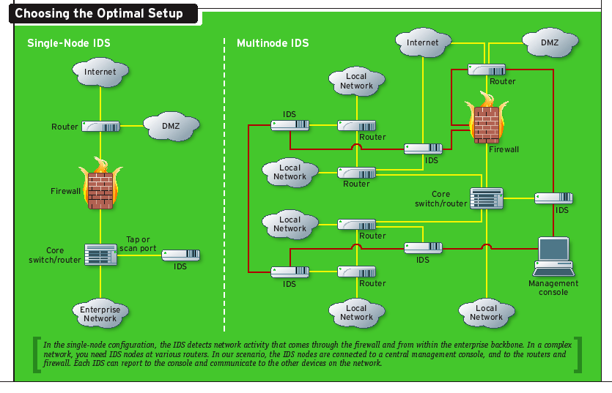
An Intrusion Detection System (IDS) is a monitoring system that detects suspicious activities and generates alerts when they are detected. Based upon these alerts, a security operations center (SOC) analyst or incident responder can investigate the issue and take the appropriate actions to remediate the threat
Classification of Intrusion Detection Systems
Intrusion detection systems are designed to be deployed in different environments. And like many cybersecurity solutions, an IDS can either be host-based or network-based.

- Host-Based IDS (HIDS): A host-based IDS is deployed on a particular endpoint and designed to protect it against internal and external threats. Such an IDS may have the ability to monitor network traffic to and from the machine, observe running processes, and inspect the system’s logs. A host-based IDS’s visibility is limited to its host machine, decreasing the available context for decision-making, but has deep visibility into the host computer’s internals.
- Network-Based IDS (NIDS): A network-based IDS solution is designed to monitor an entire protected network. It has visibility into all traffic flowing through the network and makes determinations based upon packet metadata and contents. This wider viewpoint provides more context and the ability to detect widespread threats; however, these systems lack visibility into the internals of the endpoints that they protect.

Due to the different levels of visibility, deploying a HIDS or NIDS in isolation provides incomplete protection to an organization’s system. A unified threat management solution, which integrates multiple technologies in one system, can provide more comprehensive security.
Detection Method of IDS Deployment
Beyond their deployment location, IDS solutions also differ in how they identify potential intrusions:
- Signature Detection: Signature-based IDS solutions use fingerprints of known threats to identify them. Once malware or other malicious content has been identified, a signature is generated and added to the list used by the IDS solution to test incoming content. This enables an IDS to achieve a high threat detection rate with no false positives because all alerts are generated based upon detection of known-malicious content. However, a signature-based IDS is limited to detecting known threats and is blind to zero-day vulnerabilities.
- Anomaly Detection: Anomaly-based IDS solutions build a model of the “normal” behaviour of the protected system. All future behaviour is compared to this model, and any anomalies are labelled as potential threats and generate alerts. While this approach can detect novel or zero-day threats, the difficulty of building an accurate model of “normal” behaviour means that these systems must balance false positives (incorrect alerts) with false negatives (missed detections).
- Hybrid Detection: A hybrid IDS uses both signature-based and anomaly-based detection. This enables it to detect more potential attacks with a lower error rate than using either system in isolation.
IDS vs Firewalls
Intrusion Detection Systems and firewalls are both cybersecurity solutions that can be deployed to protect an endpoint or network. However, they differ significantly in their purposes.
An IDS is a passive monitoring device that detects potential threats and generates alerts, enabling security operations center (SOC) analysts or incident responders to investigate and respond to the potential incident. An IDS provides no actual protection to the endpoint or network. A firewall, on the other hand, is designed to act as a protective system. It performs analysis of the metadata of network packets and allows or blocks traffic based upon predefined rules. This creates a boundary over which certain types of traffic or protocols cannot pass.
Since a firewall is an active protective device, it is more like an Intrusion Prevention System (IPS) than an IDS. An IPS is like an IDS but actively blocks identified threats instead of simply raising an alert. This complements the functionality of a firewall, and many next-generation firewalls (NGFWs) have integrated IDS/IPS functionality. This enables them to both enforce the predefined filtering rules (firewalls) and detect and respond to more sophisticated cyber threats (IDS/IPS). Learn more about the IPS vs IDS debate here.
Selecting an IDS Solution
An IDS is a valuable component of any organization’s cybersecurity deployment. A simple firewall provides the foundation for network security, but many advanced threats can slip past it. An IDS adds an additional line of defense, making it more difficult for an attacker to gain access to an organization’s network undetected.

When selecting an IDS solution, it is important to carefully consider the deployment scenario. In some cases, an IDS may be the best choice for the job, while, in others, the integrated protection of an IPS may be a better option. Using a NGFW that has built-in IDS/IPS functionality provides an integrated solution, simplifying threat detection and security management.

KT0306 Secure VPN configuration and management
Configuration security risks
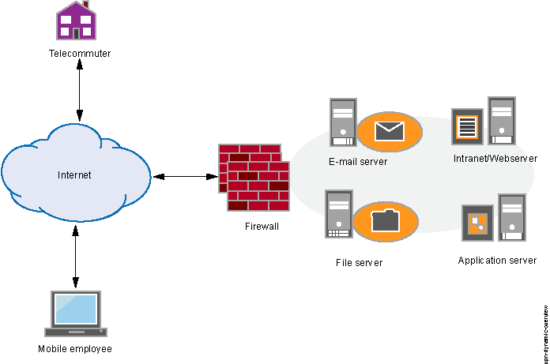
Design and implementation of a VPN can be complicated. If you’re not sure how to keep it up and running safely, consider bringing in an experienced network security professional to make sure VPN security hasn’t been compromised.
Reliability
Since VPN connections run off the Internet, you need to choose an Internet service provider (ISP) that consistently delivers excellent service with minimal to no downtime.
Scalability
If you need to add new infrastructure or create new configurations, you may run into technical problems due to incompatibility—especially if you're adding new products from different vendors.
Slow connection speeds
If you're using a VPN client that provides free VPN service, your connection speed may be slow, as these providers do not usually offer high-speed connections. Consider whether the speed is sufficient for business needs.
Should you create your own VPN, or buy one?
Instead of trying to build one yourself, you can buy a prebuilt VPN solution. If you're shopping for VPN solutions, ask questions about the ease of configuration.
Steps for setting up a VPN
6 steps to set up a VPN
Step 1: Line up key VPN components
To get started, you'll need a VPN client, a VPN server, and a VPN router. The downloadable client connects you to servers around the world, so employees everywhere can access your small business network. The client can be used on devices like smartphones and laptops, even if workers are using public Wi-Fi networks.
To secure and encrypt all network traffic, you'll also need a VPN router. Many routers come with VPN clients built-in.
Step 2: Prep devices
On occasion, VPN clients can conflict with other clients, or fail to work properly. It's a good idea to prepare your network system before you set up a VPN so that you can avoid problems down the road.
As a first step, uninstall any existing VPN client software that you don’t need. In theory, the VPN clients should be able to work well together, but competing clients can also be a source of problems, so it’s best to remove them.
This is also a good time to consider network configuration. If you plan to install a VPN for workers who'll access online resources in several ways—such as Wi-Fi, 4G modems, and wired connections—you may need to spend more time configuring the VPN client. Simplifying networks by unplugging unused devices can help.
Step 3: Download and install VPN clients
The simplest way to get your VPN up and running is to install clients from your VPN provider. However, they may not offer software for every platform you need, such as Windows, iOS, and Android. Even if they don't, it's better to install what they offer first and then confirm that your VPN account is operating correctly.
Look for the "downloads" page on your VPN provider's website. You should also download apps for the mobile devices that your workers use since you’ll want to protect connections from as many devices as possible.
If the initial client you install works right off the bat, then you can contact the VPN provider about clients for other platforms. And if you can’t log in at all, then you can pass along that information to the VPN provider's support team.
Step 4: Find a setup tutorial
If, for some reason, your VPN provider doesn't offer software for the devices your business uses, check the provider's website for guides on manual setup. Hopefully, you'll find the documentation you need. If you don't, search for other providers' setup guides that use the same devices.
For example, if your business uses Chromebooks, you can search for tutorials specifically for these devices.
Step 5: Log in to the VPN
After you install the VPN client apps, it's time to enter login information. In general, the username and password will be the ones you used when you signed up with the VPN provider, although some companies ask you to create a separate login for the VPN client itself.
Once you're logged in, the VPN app usually connects to the server nearest to your current location.
Step 6: Choose VPN protocols
VPN protocols decide how data is routed between your computer and the VPN server. Some protocols help improve speed, while others help improve data privacy and security.
OpenVPN
This is an open-source protocol, which means you can view its code. OpenVPN is also rapidly becoming an industry standard.
L2TP/IPSec
The Layer 2 Tunnel Protocol is another popular protocol. It has strong security protections and is often bundled with the IPSec protocol, which authenticates and encrypts packets of data sent over the VPN.
SSTP
The Secure Socket Tunneling Protocol is fully integrated with the Microsoft operating system.
PPTP
Point-to-Point Tunneling Protocol is one of the oldest VPN protocols. But it is becoming less widely used since there are faster and more secure protocols available.
Step 7: Troubleshoot
Usually, your VPN provider's client will start working right away. But if that's not the case, try these steps:
- Shut down and reopen the client and try rebooting your device.
- If you have any other VPN software running, make sure you're disconnected, then close it down.

KT0307 Wireless network defense
Wireless Network Defense (Archived)

The majority of work to develop and mature military wireless networks to date has focused on efficiency and stability in benign conditions. Insufficient attention has been paid to identifying and mitigating vulnerabilities arising from the new features being added to make these networks more efficient. Unfortunately, because of the focus on efficiency, the protocols that have been developed implicitly trust all information shared about the state of the nodes and the larger network. Consequently, when the information that is shared among these nodes is bad, the network quickly becomes unusable.
In particular, the protocols that have been developed for military wireless networks require the nodes in the network to coordinate among themselves to manage their resources (e.g., spectrum, time, and power) and also to organize themselves in order to provide the functionality necessary to deliver data efficiently. To meet that objective, the nodes must share information about their state and the state of the world around them, and do so in a way that is not wasteful of the precious network capacity intended for user data. With the shared information, the network nodes make decisions about configuration details such as which frequencies to use, which node gets to transmit when, and to which node(s) to forward data when a direct path to the destination does not exist. These are protocols that determine how the physical channels are used in order to provide a useful network to the devices and people using the wireless network.
As the use of wireless systems expands, the likelihood of network compromise (whether maliciously or by unwitting misconfiguration) will increase. Beyond the conventional node-by-node security in use today, a set of network-based checks are needed to ensure that misinformation inserted into the control protocols does not disable the network functionality. While this concern is particularly important to the class of emerging wireless mesh networks, it is also relevant to other topologies, such as hub-spoke, which are evolving to include self-organizing network technologies.
Acknowledging that the network can be compromised, the Wireless Network Defense program will develop and demonstrate new technology for robustly controlling wireless networks. This program will not create a new communications waveform nor develop a new tactical radio. Instead, the technology will be developed in such a way as to enable improvement in the robustness of the class of wireless networks that are being procured and fielded in the near future, and also to provide a reliable foundation on which to build the subsequent generation of wireless systems.

KT0308 Data backup and recovery
These days, it’s commonly accepted that the key to a stable and secure IT environment is a proactive approach to IT management. Most business leaders understand that anyone and everyone is a target, no matter how large or small your business. However, there are still quite a few companies out there that operate with only minimal IT protection under an “it won’t happen to me” mentality.

Network security issues go beyond criminal activity natural disasters, equipment failure, or even user error can all compromise or even destroy important data. Regardless of the catalyst, there are solutions for every scenario, but they are dependent on one question: does your company operate with a reactive or proactive approach to network security?

A reactive model is one in which a company’s IT team responds to a problem once it has already happened. There’s no way to avoid damage with this model. At best, the problem is identified quickly and the harm minimized, but there’s no such thing as “zero loss” when it comes to this approach. Ask any security IT professional the best approach is proactive network security.

Determining what and how much network security you need can be tricky if left to your own devices. Many network security companies use scare tactics to try and sell their top-level and most expensive security packages, making it difficult to know what your company really needs.

So let’s take the guesswork out of it. Check out these major factors to consider when shopping for IT security services for your business.
Proactive monitoring: When left unchecked, changes to your systems can turn into problems, both long and short term. Any complete IT solution should include constant, proactive monitoring of your entire network’s systems and operations. Proactive monitoring involves watching and documenting all incoming/outgoing data and activity so potential system threats like computer viruses, hacking attempts, and more can be caught before they result in catastrophic destruction. Proactive monitoring allows you to track the root of the problem, identifying the issue at its cause and before it becomes a bigger problem so you’re never left in the dark about what’s happening on your network.

Best practices: If most (or all) security professionals stand behind something, chances are good that your company should too. Industry best practices exist because they’ve been tested, time and again, and have proven to yield the greatest results in the greatest number of scenarios across the board. Don’t trust just one professional; trust the consensus of them all.

Backup & Recovery: Any comprehensive network security IT solution should include multiple backup systems (both on- and off-site) and a disaster recovery plan in place to ensure your company can bounce back in the event of security breach, data loss or equipment failure. This is your last line of defense, and an absolute must have for every company of every size. The consequences of data loss can be severe; in worst case scenarios, data loss can (and has) caused companies to fail completely. To your clients, data loss translates to loss of trust and confidence in your ability to keep everything running smoothly.

Communication: Often overlooked, working communication tools are a necessity for successful businesses. Email, telecommunications, and electronic data exchange (EDI) must be up and running at all times to ensure your company is freely communicating with customers, partners and vendors. Mobile devices and other communication tools have their benefits, but with the advent of bring your own device (BYOD) in the workplace, you’re faced with new potential system access points for criminals to exploit. Your IT team should implement policies and protocols designed to specifically address communication security breaches.

Network Security: The internet is brimming with threatening software and criminal activity. Because of this, antivirus programs, malware protection, spam filtering, and firewall intrusion prevention to name just a few are one side of a never-ending battle between cyber criminals and network security. With as many options available as there are criminals learning to overcome them, the best solution for any company is to choose a comprehensive network security plan that’s custom-built to suit your company’s specific network security needs.

Strategic Planning: Looking at the big picture is equally as important as looking at current challenges. A company that plans for growth is more likely to evolve, so it’s important to have a specific strategic IT plan for growth backed with a strategy for implementing that plan. Your comprehensive IT strategic plan should result in better returns on investment, due to appropriately distributed spending over reasonable timelines and well-timed technology investments that accelerate company-wide growth.

In life, sometimes you want to gamble. When it comes to your company’s network security, gambling isn’t an option. A proactive approach to network security gives your company the competitive advantage and ensures a safer future for your data.

Internal Assessment Criteria and Weight
- IAC0301Application of network security controls, protocols, perimeter appliances, secure IDS, VPN, and firewall configuration

KM-02-KT04: Monitoring for breaches and attacks
Topic elements to be covered include:
- KT0401Network traffic monitoring and analysis
- KT0402Intricacies of network traffic signature, analysis, and vulnerability scanning

KT0401 Network traffic monitoring and analysis
What is Network Traffic Analysis (NTA)?
Network traffic analysis (NTA) is a method of monitoring network availability and activity to identify anomalies, including security and operational issues. Common use cases for NTA include:
- Collecting a real-time and historical record of what’s happening on your network
- Detecting malware such as ransomware activity
- Detecting the use of vulnerable protocols and ciphers
- Troubleshooting a slow network
- Improving internal visibility and eliminating blind spots
Implementing a solution that can continuously monitor network traffic gives you the insight you need to optimize network performance, minimize your attack surface, enhance security, and improve the management of your resources. However, knowing how to monitor network traffic is not enough. It’s important to also consider the data sources for your network monitoring tool; two of the most common are flow data (acquired from devices like routers) and packet data (from SPAN, mirror ports, and network TAPs).
The key benefits of network traffic analysis
With the “it’s not if, it’s when” mindset regarding cyber-attacks today, it can feel overwhelming for security professionals to ensure that as much of an organization’s environment is covered as possible. The network is a critical element of their attack surface; gaining visibility into their network data provides one more area they can detect attacks and stop them early. Benefits of NTA include:
- Improved visibility into devices connecting to your network (e.g., IoT devices, healthcare visitors)
- Meet compliance requirements
- Troubleshoot operational and security issues
- Respond to investigations faster with rich detail and additional network context
A key step of setting up NTA is ensuring you’re collecting data from the right sources. Flow data is great if you are looking for traffic volumes and mapping the journey of a network packet from its origin to its destination. This level of information can help detect unauthorized WAN traffic and utilize network resources and performance, but it can lack rich detail and context to dig into cybersecurity issues.
Packet data extracted from network packets can help network managers understand how users are implementing/operating applications, track usage on WAN links, and monitor for suspicious malware or other security incidents. Deep packet inspection (DPI) tools provide 100% visibility over the network by transforming the raw metadata into a readable format and enabling network and security managers to drill down to the minutest detail.
The importance of network traffic analysis
Keeping a close eye on your network perimeter is always good practice. Even with strong firewalls in place, mistakes can happen and rogue traffic could get through. Users could also leverage methods such as tunnelling, external anonymizers, and VPNs to get around firewall rules.
Additionally, the rise of ransomware as a common attack type in recent years makes network traffic monitoring even more critical. A network monitoring solution should be able to detect activity indicative of ransomware attacks via insecure protocols. Take WannaCry, for example, where attackers actively scanned for networks with TCP port 445 open, and then used a vulnerability in SMBv1 to access network file shares.
Remote Desktop Protocol (RDP) is another commonly targeted application. Make sure you block any inbound connection attempts on your firewall. Monitoring traffic inside your firewalls allows you to validate rules, gain valuable insight, and can also be used as a source of network traffic-based alerts.
Watch out for any suspicious activity associated with management protocols such as Telnet. Because Telnet is an unencrypted protocol, session traffic will reveal command line interface (CLI) command sequences appropriate for the make and model of the device. CLI strings may reveal login procedures, presentation of user credentials, commands to display boot or running configuration, copying files, and more. Be sure to check your network data for any devices running unencrypted management protocols, such as:
- Telnet
- Hypertext Transport Protocol (HTTP, port 80)
- Simple Network Management Protocol (SNMP, ports 161/162)
- Cisco Smart Install (SMI port 4786)
What is the purpose of analysing and monitoring network traffic?
Many operational and security issues can be investigated by implementing network traffic analysis at both the network edge and the network core. With the traffic analysis tool, you can spot things like large downloads, streaming or suspicious inbound or outbound traffic. Make sure you start off by monitoring the internal interfaces of firewalls, which will allow you to track activity back to specific clients or users.
NTA also provides an organization with more visibility into threats on their networks, beyond the endpoint. With the rise in mobile devices, IoT devices, smart TV’s, etc., you need something with more intelligence than just the logs from firewalls. Firewall logs are also problematic when a network is under attack. You may find that they are inaccessible due to resource load on the firewall or that they’ve been overwritten (or sometimes even modified by hackers), resulting in the loss of vital forensic information.
Some of the use cases for analysing and monitoring network traffic include:
- Detection of ransomware activity
- Monitoring data exfiltration/internet activity
- Monitor access to files on file servers or MSSQL databases
- Track a user’s activity on the network, though User Forensics reporting
- Provide an inventory of what devices, servers and services are running on the network
- Highlight and identity root cause of bandwidth peaks on the network
- Provide real-time dashboards focusing on network and user activity
- Generate network activity reports for management and auditors for any time period
What to look for in a network traffic analysis and monitoring solution
Not all tools for monitoring network traffic are the same. Generally, they can be broken down into two types: flow-based tools and deep packet inspection (DPI) tools. Within these tools you’ll have options for software agents, storing historical data, and intrusion detection systems. When evaluating which solution is right for your organization, consider these five things:
- Availability of flow-enabled devices: Do you have flow-enabled devices on your network capable of generating the flows required by a NTA tool that only accepts flows like Cisco NetFlow? DPI tools accept raw traffic, found on every network via any managed switch, and are vendor independent. Network switches and routers do not require any special modules or support, just traffic from a SPAN or port mirror from any managed switch.
- The data source: Flow data and packet data come from different sources, and not all NTA tools collect both. Be sure to look through your network traffic and decide which pieces are critical, and then compare capabilities against the tools to ensure everything you need is covered.
- The points on the network: Consider whether the tool uses agent-based software or agent-free. Also be careful not to monitor too many data sources right out the gate. Instead, be strategic in picking locations where data converges, such as internet gateways or VLANs associated with critical servers.
- Real-time data vs. historical data: Historical data is critical to analysing past events, but some tools for monitoring network traffic don’t retain that data as time goes on. Also check whether the tool is priced based on the amount of data you want to store. Have a clear understanding of which data you care about most to find the option best suited to your needs and budget.
- Full packet capture, cost and complexity: Some DPI tools capture and retain all packets, resulting in expensive appliances, increased storage costs, and much training/expertise to operate. Others do more of the 'heavy lifting,’ capturing full packets but extracting only the critical detail and metadata for each protocol. This metadata extraction results in a huge data reduction but still has readable, actionable detail that’s ideal for both network and security teams.

KT0402 Intricacies of network traffic signature, analysis, and vulnerability scanning
Intrusion detection has become big business on the Internet and, to be honest, it’s not surprising. With the profusion of e-commerce web sites, on-line banking and other high-profile applications, it’s fully understandable that organisations should want to avail themselves of the best possible protection against unauthorised system entry.
In truth, the threat of network intrusion is much wider than those heavily publicised incidents of web site defacement would have us believe. It would also be a misnomer to imply that this is merely an Internet-only problem.
The threat of network intrusion hangs heavy over any organisation that possesses a network open to the outside world. And, in taking that particular statement on board, we open up the true dangers inherent in virtually every Internet protocol network. That, by definition, involves virtually every computer network in existence today – networks used for everything from process industry control through to Internet banking and office automation.
Connectivity is the byword
Since the byword of almost every modern organisation is connectivity, even those companies that have no direct Internet presence remain vulnerable to hacker attack and intrusions.
Just because you don’t have a web site or, equally, because your site doesn’t feature any e-commerce capabilities, that doesn’t make you immune to the possibility of someone gaining unauthorised access to your network.
Just think about it for a moment. Most organisations running a network have the capability to allow members of staff and even outside contractors to connect to their systems remotely. This makes it easier for workers to connect from home, or while on the move. Importantly, it also renders the network susceptible to unauthorised entry by unwelcome third parties.
And therein, as they say, lies the rub. Our modern work practices make it essential that we provide a reasonable degree of external connectivity to our networks, regardless of whether we are a bank or a financial institution (or even an e-commerce site with sensitive customer data just waiting to be exposed).
The fact is, then, that virtually every organisation running anything other than a perfectly closed loop network is leaving itself open to possible intruder attack.
So what’s the answer? Well, one of the most prevalent solutions is the installation of a sophisticated firewall system. Undoubtedly, this can help in ‘hiding’ major parts of your system from unwanted attention. However, the problem remains that we still need to provide external connectivity, data communications, Internet access and maybe even Voice-over-IP for the organisation as a whole. Inevitably, this means that the firewall cannot be used simply to pull the proverbial shutters down.
The need to communicate brings us the necessity to search for a second line of defence. That’s where intrusion detection comes into the equation. As there’s no universally adopted definition of what this actually is, it’s probably easier to describe the whole concept by reference to more familiar analogies.
Access to the network
Think of intrusion detection as a well-trained guard dog and you’ll derive the general idea. Now imagine that the rooms in your home represent your network, and the perimeter fence around the garden is standing in for the firewall. You need to gain access to the outside world and, equally, authorised guests, visitors and invitees must be able to enter your property. After all, how else would you be able to receive the morning post and newspapers, and have the electricity and gas meters read?
Being the prudent householder, you’ll realise that there’s a distinct possibility some visitors to your premises will not be welcome. Now, because you have a gate to allow you to mingle with the outside world, and vice versa, this leaves you vulnerable to the attentions of such undesirable elements – the networking equivalent of double-glazing salesmen or, worse still, burglars. This is the time when your trusty guard dog makes its presence felt.
Due to the fact that he or she has been trained to sniff out unwanted guests, it duly sounds a warning whenever it detects the presence of any unauthorised third party coming through the gate. This is the basis of intrusion detection.
That said, as you can imagine not all guard dogs are perfectly trained. Some will happily bark at anything or anyone that approaches your gate, while others will sit down and wait to be patted as the burglar walks past and strolls into your lounge. Thus, we have a problem. While there are many intrusion detection solutions on the market, some are more efficient than others in the elimination of what we call ‘false positives’, as well as in the correct identification of unauthorised traffic.
Most intrusion detection systems are what is known as signature-based, meaning that they operate in much the same way as a virus scanner by searching for a known identity (or signature) for each specific intrusion event. And, while signature-based intrusion detection is very efficient at sniffing out known styles of attack, it does – much like anti-virus software – depend on receiving regular signature updates such that it can stay in touch with variations to hackers’ techniques.
In other words, signature-based intrusion detection systems are only as good as the database of stored signatures. It’s a bit like training our proverbial guard dog to watch the front door, but then forgetting to tell it to watch the back of the house as well.
As signature-based intrusion detection can only ever be as good as the extent of the database, further problems immediately arise. For one, it becomes all-too-easy to fool signature-based solutions by changing and obfuscating the ways in which an attack is made. This technique simply skirts around the signature database stored in the detection system, offering the hacker an ideal opportunity to gain access to the network.
Hackers like a challenge
Make no mistake that hackers enjoy a challenge, and like nothing better than to be able to test their software and pit their skills against many of the commercially-available intrusion detection systems. As the attacker knows that the intrusion system will trigger an alarm when it detects certain attack signatures, that hacker will tend to evade detection by disguising the attack.
For example, hackers are aware that signature-based intrusion detection systems traditionally have a problem with the complexities of application interactions. This is compounded by the fact that application protocols have become increasingly complex as they expand to provide support for features like Unicode.
Briefly, Unicode allows uniform computer representation of every character in every language by providing a unique code point or identifier for each character. It’s a standard requirement of well-known computer languages such as Java and XML, making it a feature of many modern operating systems. As signature-based intrusion detection can miss characters written in Unicode Transformation Format, it then becomes relatively easy for an attacker to submit a URL containing an exploit that would allow other programs to be run and files to be accessed.
Due to these known problems, signature-based intrusion detection is really only suited to very basic levels of protection. For any organisation wanting to implement a more thorough – and hence safer – solution, it’s better to use anomaly-based intrusion detection. By its very nature, this is a rather more complex animal.
In fact, to borrow once more from our earlier analogy, it’s like our guard dog personally interviewing everyone at the gate before they’re allowed to walk down the driveway.
Anomaly-based detection
In network traffic terms, anomaly-based intrusion detection captures all the headers of the IP packets running towards the network. From here, it filters out all known and legal traffic (including web traffic) to the organisation’s web server, mail traffic to and from its mail server, outgoing web traffic from company employees and DNS traffic to and from its DNS server.
Even though this level of filtering significantly narrows down the amount of data to be analysed, anomaly-based intrusion detection can still create large amounts of log data. This is then analysed using database functionality. Since anomaly-based intrusion detection sees all of the traffic running into the network, there are far fewer places in which to conceal malicious hacker codes.
There are other equally obvious advantages to using anomaly-based detection systems. For example, because it detects any traffic that’s either new or unusual, this method is particularly good at identifying sweeps and probes towards network hardware. Therefore, it can give early warnings of potential intrusions (probes and scans are the predecessors of all attacks).
The more targeted the probes and scans, the more likely that the hacker is serious about attacking your network. Equally, the technique is ideal for detecting every new piece of hardware installed on the network. This applies to any new service installed on any item of hardware and forgotten about when the maintenance was finished.
As such, anomaly-based intrusion detection is perfect for detecting anything from port and web anomalies through to misinformed attacks where the URL is deliberately typed incorrectly.
Some Internet security commentators argue that effective anomaly testing isn’t possible. They claim that, because the technique requires trained human resources, not to mention sophisticated hardware and software, the procedures involved simply aren’t viable.
Admittedly, anomaly testing requires more hardware spread further across the network than is required with signature-based solutions. This is particularly true for larger networks and, with the bandwidth connections, it’s therefore necessary to install the anomaly sensors closer to the servers and network being monitored.
The rationale here is that the amount of data is lessened the closer the sensors are to the application than if they were located close to or at the network backbone. Placing them too close to the main backbone simply results in too much data being detected.
However, none of this detracts from the inescapable fact that anomaly testing is a more effective way of pinpointing possible attacks. In fact, most of the operational criticisms levelled against anomaly-based intrusion detection systems are equally applicable to signature-based testing.
Both methods need tuning to reduce the number of false alerts. Very important, as the temptation to tune a system too tightly can cause the loss of some of the ‘events of interest’ that you’re hoping to detect.

Internal Assessment Criteria and Weight
- IAC0401Procedures for monitoring of breaches and attacks are compared

KM-02-KT05: Network incident response and management
Topic elements to be covered include:
- KT0501Incident response plan
- KT0502Incident response process
- KT0503Reporting and documentation
- KT0504Lessons learnt

KT0501 Incident response plan
A sufficient incident response plan offers a course of action for all significant incidents. Some incidents lead to massive network or data breaches that can impact your organization for days or even months. When a significant disruption occurs, your organization needs a thorough, detailed incident response plan to help IT staff stop, contain, and control the incident quickly. For physical disruptors, such as natural disasters and flooding, create a disaster recovery plan.
What is an incident recovery team?
An incident recovery team is the group of people assigned to implement the incident response plan. Generally, these are members of the IT staff who collect, preserve, and analyze incident-related data. Your IT staff may need to work with lawyers and communications experts to make sure that legal obligations are met.
Why do you need an incident response plan?
If your network hasn’t been threatened yet, it will be. If it has, then you know the chaos that can follow a cyber attack. Whether a threat is virtual (security breaches) or physical (power outages or natural disasters), losing data or functionality can be crippling. An incident response plan and a disaster recovery plan help you mitigate risk and prepare for a range of events.
How can you be sure your network is ready for a disaster?
Your network will never be 100 percent secure, so you must prepare both your network and your employees for crises to come. In addition to an incident response plan, you need a thorough disaster recovery plan that can mitigate the damage caused by a disaster.
How to create an incident response plan
1. Determine the critical components of your network
To protect your network and data against major damage, you need to replicate and store your data in a remote location. Because business networks are expansive and complex, you should determine your most crucial data and systems. Prioritize their backup, and note their locations. These actions will help you recover your network quickly.
2. Identify single points of failure in your network and address them
Just as you should back up your data, you should have a plan B for every critical component of your network, including hardware, software, and staff roles. Single points of failure can expose your network when an incident strikes. Address them with redundancies or software failover features. Do the same with your staff. If a designated employee can’t respond to an incident, name a second person who can take over. By having backups and fail-safes in place, you can keep incident response and operations in progress while limiting damage and disruption to your network and your business."
3. Create a workforce continuity plan
During a security breach or a natural disaster, some locations or processes may be inaccessible. In either case, the top priority is employee safety. Help ensure their safety and limit business downtime by enabling them to work remotely. Build out infrastructure with technologies such as virtual private networks (VPNs) and secure web gateways to support workforce communication.
4. Create an incident response plan
Draw up a formal incident response plan, and make sure that everyone, at all levels in the company, understands their roles.
An incident response plan often includes:
- A list of roles and responsibilities for the incident response team members.
- A business continuity plan.
- A summary of the tools, technologies, and physical resources that must be in place.
- A list of critical network and data recovery processes.
- Communications, both internal and external.

5. Train your staff on incident response
Only IT may need to fully understand the incident response plan. But it is crucial that everyone in your organization understands the importance of the plan. After you’ve created it, educate your staff about incident response. Full employee cooperation with IT can reduce the length of disruptions. In addition, understanding basic security concepts can limit the chances of a significant breach.

KT0502 Incident response process
When responding to cybersecurity incidents for our clients, Nettitude follow the CREST Cybersecurity Incident Response process, which is broken down into 3 phases, as shown in the following graphic:
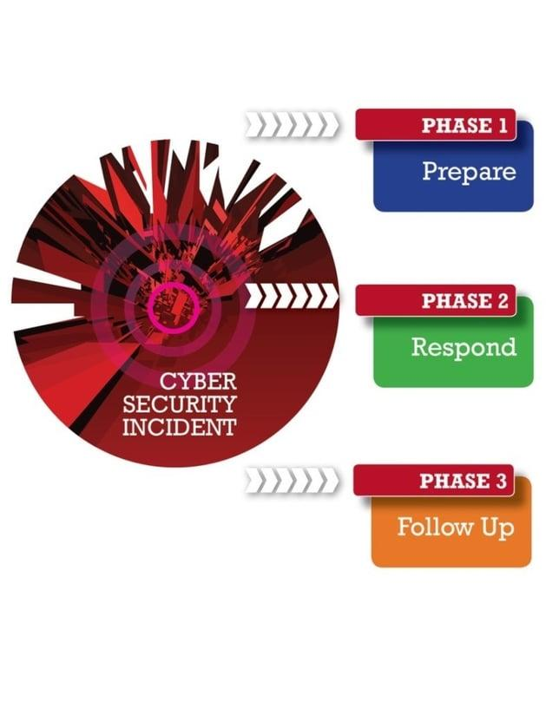
Arguably, the incident response planning phase 1 is the most important phase as all the activities in the remaining two phases flow from the activities in phase 1. Let’s have a closer look at the 3 phases of the Cybersecurity Incident Response process.

1 - Prepare with Incident Response Planning

Planning Mistakes
Failing to plan is planning to fail, so the saying goes and this is particularly true in respect to Incident Response. It is essential that you have a robust Incident Response plan and policy in place. Your Incident Response plan needs to be moderately high level, establishing who gets contacted and at what point during the Respond phase of the Incident Response process. One of the common mistake’s we often see is to develop a very detailed plan that describes very complex technical responses to a variety of threats; thus when an incident occurs your responders have to wade through >100 pages of documentation to establish what they need to do. If your plan is more than 25 pages in length then it is probably sub-optimal. You can buttress your Incident Response plan with play-books for defined incident types, but extensive technical actions generally shouldn’t be included in your Incident Response plan.

Testing the Plan
Once you have developed an Incident Response plan you absolutely must test it via a table-top exercise. This will facilitate the identification of any further gaps in your Incident Response process; you should seek to bridge those gaps at the earliest opportunity. You certainly don’t want to be in a position where your first run through the plan is during a live incident.

Being in a General State of Readiness
The preparation phase of the Incident Response process goes well beyond developing a plan. Organisations should assess their general state of readiness for a cybersecurity incident and consider the role of people, process and technologies in respect of their readiness. Nettitude typically find that the pinch points in the Response phase of a security incident relate to access to log data or other forensic artefacts. These generally occur due to their being no log retention policy in place, thus the log data has “rolled over”, or that there is no agreement in place with I.T. MSPs around producing log data in a timely fashion. These types of issues should be addressed when you are developing your Incident Response plan.
Nettitude also frequently find that organisations do not perform any form of asset discovery or asset management. This makes establishing the scope of an incident extremely challenging as the number of assets in an environment and what services that those assets are running cannot be determined without additional technical work.
Organisations also need to consider the I.T security posture of other organisations in their supply chain during the Prepare phase of the Incident Response process. Do you know if those organisations have their own Incident Response plan in place? Do you have a “right to inspect” the Incident Response documents held by organisations in your supply chain?

2 - The Incident Response Itself
As we stated in the introduction, if you have prepared well, then the Response phase should go a lot more smoothly. That in no way implies that this phase will be “simple”, just that your response will be hewn to a robust process with, hopefully, no insurmountable obstacles preventing you resolving the incident.

What Steps to Take
It is important that you investigate the event or alert that triggered the Response phase of the Incident Response process. Far too often we see organisations setting the hares running by pulling back logs from a range of log sources looking for suspicious entries. Experienced Incident Response investigators will know that log sources are generally full of suspicious entries, mostly benign and mostly not connected to the event or alert that was triggered.
Your first step should therefore be to investigate the initial event that triggered the alarm and determine if it is a false positive. Nettitude have noted that the direction of the Response phase is often dictated by the description of the event or alert. A series of failed authentications on the internal network are often categorised as a brute force attack; when this is escalated into an organisations Incident Response process, there is an immediate assumption that the environment has already been compromised and that the attacker is now brute forcing further user accounts. Experienced Incident handlers will know that in the vast majority of cases, these types of alerts are benign and most likely associated with a password synching issue. It is therefore important that following the receipt of an alert, the incident handler drills down to establish what precisely has been alerted upon and that they consider all possible alternative explanations for the generation of the alert. It is only through completing these steps that the appropriate action can be taken in respect of the alert.
Nettitude strongly recommend that the objective of the Response phase be written down and communicated to all the staff who will be involved in the response. This is crucial to identifying the most valuable investigative steps. There are potentially dozens of lines of enquiries or investigative steps that might be taken but many of those options will have no value in helping you achieve the objective of the response.

Recovery of Systems
Part of the Response phase will include the recovery of systems; this involves returning them to a state where you have a high degree of confidence that they are no longer compromised. It is important that you preserve all of the data necessary to complete the investigation BEFORE you move into recovery. Nettitude often encounter situations where organisation move into recovery almost as soon as an incident is detected. This will manifest itself in situations where, during a ransomware attack, critical systems that have been impacted are taken offline and rebuilt so that they can be returned to service. We then find that those systems were hosting critical data such as firewall logs that have now been destroyed.

Our Recommendations -
Nettitude strongly recommend that organisations adopt a “zero risk” approach to remediation and recovery in the Response phase of the Incident Response process. Simply removing a known malicious binary and putting the compromised host back into the production environment is incredibly risky. Many families of malware will seriously degrade the security posture of a system by modifying registry keys or disabling security processes such as anti-virus, simply removing the malware will not reverse those changes and often malware will make hundreds of changes to the configuration of an infected system, so simply reversing the changes is not feasible.

3 - Follow Up with an Incident Response Report
This is the final phase of the Incident Response process. In Nettitude’s experience, it is often the most poorly executed phase. The follow up phase should be used to conduct a deeper dive into the data you gathered to ensure that you have identified, as much as possible, the tools, techniques and processes that the threat actor used against your organisation. Once you have identified these TTPs you should update your controls to ensure that they cannot be deployed against you undetected in the future.

Creating an Incident Report
A thorough post incident response report should be created in order to identify the lessons learned and establish if your Incident Response plan worked as expected. Any gaps in your people, processes and technologies should also be identified during the post incident review and these gaps should be bridged as soon as possible.

KT0503 Reporting and documentation
What should be in an incident response report?
Summarize the incident – what was the impact on the organization, what were the root causes that allows the attack to happen, the final timeline of the incident, and most importantly – what went well in the incident management process and what needs to be improved next time.

KT0504 Lessons learnt
What is Incident Response?
For most businesses, a cybersecurity attack is not a matter of “if,” but “when.” Incident response is how you respond to that attack when it happens. The goal of incident response is not only to get you back up and running after a breach, but to also have the evidence forensically preserved so that a thorough investigation can be performed to assist in determining if there was a data privacy breach.
As the cost of breaches rises, as well as the length of the breach lifecycle, the sophistication levels of attacks are also rising. In order to ensure that you are prepared for a breach and that any breaches are fully contained, the IBM report recommends working with a managed security services provider.
What You Can Learn from Incident Response
One thing is for sure: the worst time to think about your incident response plan is when you are responding to an incident. That’s why we’ve compiled the top three lessons we’ve learned in incident response that can help you proactively plan for the future and make your organization more secure.

References
https://codered.eccouncil.org › course › network-defens..
https://www.checkpoint.com › Secure The Network
https://www.sciencedirect.com › topics › computer-science
https://www.forcepoint.com › cyber-edu › defense-depth
https://www.cisco.com › Products & Services › Security
https://www.techtarget.com › searchsecurity › definition
https://www.itgovernance.co.uk › what-is-cybersecurity
https://www.gartner.com › topics › cybersecurity
https://www.ibm.com › za-en › topics › mobile-security
https://www.archonsecure.com › mobile-device-guide

